Thank you for purchasing the TAPR WSPR Transmitter. Below are the steps to get it up and running. This page is intended as a starting point. The remainder of the instructions can be downloaded from the TAPR website -

https://tapr.org/product/wspr/

The download links are located at the bottom of the page.

In addition to the WSPR kit, you'll also need the following to have a complete WSPR transmitter -

- Raspberry Pi 2, 3 or 4 (Pi). We recommend getting a Pi 3 or 4. They have built in WiFi and faster processor (the Pi 2 does not) … One source is Adafruit (https://www.adafruit.com/?q=raspberry+pi&sort=BestMatch). We have no connection with Adafruit.

- 2.5 amp power supply w/micro USB connector. This plugs into the micro USB connector of the Pi. Adafruit is one source (https://www.adafruit.com/product/1995). A word of caution: don't cheap out on the power supply. A weak power supply will cause intermittent problems that are very hard to diagnose. Make sure the power supply will deliver at least 2 amps, and preferably more. This is cheap insurance.

- Ethernet cable. You need to connect the Pi to your network over Ethernet (wired connection) for initial setup. You can switch to WiFi after that.

- WiFi USB dongle. You only need this if you're using an Pi 2 and you want to use WiFi. Here is a WiFi dongle example: https://www.adafruit.com/product/2810.

- Contact us at contact@tapr.org for help or troubleshooting.

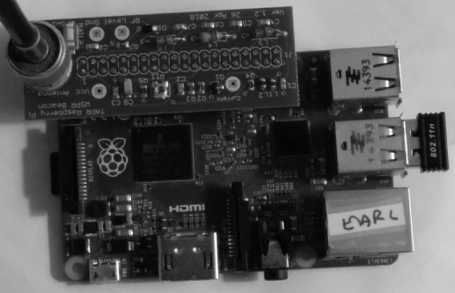

Happy WSPRing!
73, TAPR

