Marco Bersani

-----------------------------------------------------

APRS
PERFORMANCE AND LIMITS

-----------------------------------------------------

Rev. 1.02 Aug. 2020

Table of contents

CHAPTER 1: Introduction 4
1.1 What is APRS 4
1.2 APRS digipeating 4
1.3 Operation of the APRS radio network 5
CHAPTER 2: Access to the shared channel 7
2.1 APRS frames and transmission channel capacity 7
2.2 Performance and limitations of the ALOHA protocol 8
2.3 CSMA: listen before transmitting 11
CHAPTER 3: APRS networks with a single digipeater 13
3.1 APRS network with a single isofrequency digipeater 13
3.2 More efficiency: one digipeater, multiple uplink channels 17
3.3 APRS network with an analog repeater? 19
CHAPTER 4: Performance and limitations of the current APRS network 20
4.1 Impact of multiple digipeaters on an isofrequency network 20
4.2 Multiple Digipeating 23
CHAPTER 5: New possible arrangements 26
5.1 Foreword 26
5.2 A minimally invasive intervention: add a listening channel 26
5.3 Greater efficiency: a network articulated into two levels 27
5.4 IGATES: widespread listening and broadcastings 28
CONCLUSIONS 31
Bibliography 32

Copyright (c) 2020 Marco Bersani
Permission is granted to copy, distribute and/or modify this document under the terms of the GNU Free Documentation License, Version 1.3 or any later version published by the Free Software Foundation
Contacts: Marco Bersani, IK2PIH, bermarco72@gmail.com

Author's note

The APRS network has great potential on paper: the ability to track mobile stations, send weather data, telemetry and messages, all with the old equipment for the packet radio at 1200 baud AFSK, isofrequency and almost in real time.
Almost all users, however, have experienced difficulty using it, due to the congestion that occurs as soon as a fairly limited number of active stations send reports and messages.
In recent years, several strategies have been carried out to improve the performance of the existing network, by optimizing the network protocol with the introduction of new rules (new paradigm), by inviting stations to transmit at the bare minimum, by discouraging multiple digipeating and by rationalizing the distribution of digipeaters through the territory; however, it's not there yet a quantitative analysis of the efficiency of the system architecture that could serve as a guide to identify the main critical issues and to formulate coherent reorganization proposals.
It does not help the collection of statistics of the packets received and retransmitted by the digipeaters because collision information, essential for performance evaluation, is missing.
Unfortunately, the theoretical study of the APRS network is difficult for a number of reasons, including the generation of not completely random traffic, the variety and heterogeneity of hardware and software used, the coexistence of different mechanisms for accessing the shared channel, partly CSMA and partly ALOHA, the typical capture phenomenon of FM modulation (the strongest signals obscure the weakest signals), the noise of the radio channel.
Heavy simplifications are necessary to build a model that is simple enough to be treated with elementary means; the model proposed in the following pages does not pretend to accurately describe the functioning of the APRS network but wants to be a useful tool to evaluate its performance and to formulate reflections on possible new arrangements.

Note to the English version

I translated this book into English from Italian by myself, using Google translator and my limited knowledge of English (I ended studying English many years ago), so I am aware that this book needs a better translation and several adjustments. I hope it is understandable anyway and I apologize for the mistakes I definitely made. But above all, I hope readers will find the reflections I wanted to share with them useful and interesting.
The author

CHAPTER 1
Introduction

1.1 What is APRS
The APRS (Automatic Packet Reporting System) is a radio localization system developed by a radio amateur, Bob Bruninga, in the early nineties of the last century.
It was created as an experimental civil protection aid project in accordance with the obligations / duties of the radio amateur to make himself available together with his equipment in case of insufficient normal civil communications.
It is based on the transmission of digital packet radio signals and allows the dissemination of information on position, speed, direction and operating status of amateur radio stations, with the possibility of displaying data in real time on maps in the form of icons.
It also allows to send weather data, telemetry, information on emergency situations (road accidents, civil warnings and similar) and to exchange very short text messages.
To efficiently disseminate information to all stations on the network despite the reduced communication speed (1200 bps) it uses a "one to many" type protocol on a single radio channel in unconnected mode (UI frames of the AX.25 protocol ) without the certainty that the recipient receives what has been sent.
Network coverage depends on the number of digital repeaters ("digipeaters") present in the area, which automatically forward local signals to the most distant stations.
Furthermore, if there is an IGATE internet access station in the area, the signals also reach the web and are visible all over the world.
Mobile stations, if equipped with a GPS receiver connected to the radio, can be located on the maps during their march.
To access the network via radio, a transceiver on the 144 MHz frequency is required (but there are frequencies destined for APRS also in short waves) connected to a PC with sound card or to an external TNC (modem); there are commercially available transceivers with built-in TNC.
To operate exclusively from the Internet (without the use of the transceiver), a PC or mobile phone with special software and an internet connection is sufficient.
And, of course, a valid radio amateur callsign is required, usually issued after passing an exam.
The reduced transmission speed can cause congestion on the radio channel if the stations are too numerous and / or configured with unnecessary or too frequent transmissions. To operate APRS via radio you should be aware of the functionality and limitations of the system.
If you access via the internet, however, you do not have these limitations and in a few seconds you can easily receive data from hundred of stations located in a wide area around you.

1.2 APRS digipeating
"Digipeater" is short for "digital repeater", a repeater for packet data instead of voice. Unlike a standard analog voice repeater, which receives on one frequency and retransmits everything it hears (useful information and noise) simultaneously on another frequency, the digipeater receives a packet of data, records it in an internal memory and then, a moment later, retransmits it, regenerated, usually on the same frequency.
Digital regeneration of the signal at each repetition is indispensable: signals that are not completely clean, suitable for the voice, may not be suitable for data transmission; disturbances not noticeable on the voice could be fatal for a packet data transmission.
In general, the appropriate signal levels for voice are not suitable for data packets, because in data transmission an entire packet must be received perfectly to retrieve any information contained therein.
This is the reason why in digital transmissions it is preferred to regenerate the signals every time they are repeated rather than repeating the analog signal that carries the digital information, even if this involves a certain delay in the propagation of digital signals through repeater chains.
Digpeating is also much more critical for APRS than for conventional packet radio because APRS involves transmitting packet data to and from moving vehicles, while conventional packet radio is mainly used between fixed locations, usually with better antennas and more power.
Furthermore, with APRS there is no handshaking process: the sender transmits the packets and hopes that the recipients will receive them without errors. The receiving stations simply ignore the bad packets. This is the price of the one-to-many transmission nature of APRS compared to the connected nature of traditional packet radio.
Lastly, each transmission made on the same channel occupies not only the time taken by the original user to send it, but two, three additional time slots depending on the number of retransmissions required.
The indiscriminate use of three, four or more repetitions can significantly reduce the channel capacity.

1.3 Operation of the APRS radio network
The APRS network is made up of digipeaters located in favorable positions (wide radio coverage), all operating on the same frequency and identified by a radio amateur callsign and a generic alias, the same for all digipeaters.
APRS stations can transmit their packets locally, without requiring repetition by the digipeaters (even if this rarely happens) or request their packets to be repeated by one more digipeaters; in this case they can explicitly specify the sequence of digipeaters they want to use (this circumstance does not occur frequently) or, more often, simply require their packets to be repeated one or more times, referring to the digipeaters with their generic aliases (generic digipeating).

Generic digipeating is a very effective way for spreading APRS packets because stations that ask to be repeated do not have to know the structure of the network (this is particularly useful for mobile stations) and in the case of multiple repetitions the APRS packets can be diffused in all directions (UI flooding phenomenon).

Traditionally the digipeaters of the APRS network were divided into two categories: digipeaters with WIDE aliases, located in favorable geographical locations with wide radio coverage, and stations with RELAY aliases, often the same clients of the network.
The traditional "RELAY, WIDE" transmission path required the help of nearby cooperating home stations as a first step in the APRS network.
Usually WIDE digipeaters also responded to the "RELAY" alias, so a WIDE digipeater could also serve as the first step.
If you wanted to be repeated several times, you had to specify paths like "RELAY, WIDE, WIDE".
Fixed stations that were able to be heard directly by WIDE digipeaters could specify WIDE or WIDE,WIDE type routes, avoiding reliance on RELAY stations, with benefit for local traffic.
As in the conventional packet radio, each digipeater in the chain "canceled" the callsign to which it had answered by adding an asterisk.
This type of path worked with any type of TNC used as a digipeater, (a dedicated firmware was not necessary) but it increased the size of the packets and, since the TNCs were not able to recognize the packets they had already repeated, caused unnecessary duplication of the packets if more than two WIDE repeats were performed.

With the growing popularity of APRS, channel congestion increased significantly.
To solve these problems since the second half of the 2000s (in Europe since 2008), a completely new convention was introduced.
The "New paradigm" path convention completely discards the use of "RELAY" and "WIDE" and uses only WIDEn-N type paths, already foreseen in the original specifications of the APRS protocol.
In addition, digipeaters currently have internal firmware that can detect duplicate packets and avoid retransmitting them - but only if the path is a WIDEn-N path - and you can set them to ignore (or truncate) too long paths.
This significantly reduces channel congestion caused by duplicate packets and blocks out-of-area noise caused by the abuse of excessive repetitions.

To guarantee mobile stations the support of fixed stations in poorly covered areas, as happened with the RELAY stations, the new paradigm provides for the possibility of configuring home stations in a favorable position as "fill-in digipeaters" enabling digipeating with alias "WIDE1-1".
Mobile stations can thus use paths of the type "WIDE1-1, WIDE2-1" relying indifferently for the first jump on real digipeaters or on "fill-in digipeaters".

The "fill-in digipeaters", however, must be activated with caution and only if in the area access to the WIDE digipeaters by mobile / portable stations is difficult: the indiscriminate activation of these repeater stations causes in fact unnecessary duplication of packets and consequent reduction of the radio channel capacity.

Finally, the diffusion of the internet makes it possible today another particularly efficient mode of operation of the APRS network which uses gateways between the radio network and the web ("IGATES" stations).
Numerous IGATES listening stations are currently operating throughout the territory, forwarding the packets they receive to a network of servers on the internet (APRS-IS).
By connecting to the APRS-IS network via client software or special websites (for example aprs.fi) it is possible to view on maps APRS traffic from all over the world.
There are also IGATES stations operating in reverse, transferring part of the information from the APRS-IS servers to the radio channel; their use, however, is discouraged because the capacity of the radio channel is limited and is easily saturated by the considerable amount of information - even filtered - coming from the internet.

CHAPTER 2
Access to the shared channel

2.1 APRS frames and transmission channel capacity
The transmission of APRS data takes place on a single radio channel of the two meters band with AFSK modulation at 1200 bps, obtained by injecting into the microphone input of an FM transmitter an audio signal generated by a Bell202 modem.
It is a suboptimal solution from different points of view (low spectral efficiency, low transmission speed, sensitivity to disturbances), motivated by the low cost availability of the Bell modem in the years in which the standard was introduced (early '80s of the last century) and the possibility to transmit data with equipment designed for voice communications.
To estimate how many frames it is possible to transmit on such a shared channel, it is first necessary to evaluate the average length of an APRS frame (packet).
The APRS protocol uses only AX25 unnumbered information frames and divides the UI packet into seven sections as described in the following table:

1 | Flag | 1 byte | 01111110 (hex 7E), delimits the start of the packet
2 | Address | 21 bytes | Source (7bytes), destination (7bytes), digipeater (7bytes)
3 | Control | 1 byte | hex 03 (frame UI)
4 | Protocol ID | 1 byte | hex F0 (no layer 3 protocol)
5 | Information | 128 bytes | The length of the field depends on the type of information, usually 80-90 bytes but can go up to 209 bytes.
6 | Frame Check Sequence | 2 bytes | CRC, 16-bit number calculated from source and destination, used to verify the integrity of the packet.
7 | Flag | 1 byte | 01111110 (hex 7E), delimits the end of the packet

Table: structure of an APRS frame

The overall length of a frame is on average equal to 155 bytes, to which must be added 45 bytes of flags (hex 7E) transmitted at the beginning to allow time for the devices to switch to transmission, assuming a transmission delay (txdelay) of 0,3s at the speed of 1200bps.
In total, the length of an APRS packet (frame) is on average 200 bytes; at the speed of 1200 bps each frame takes on average 1.33 seconds to transmit.
In APRS technology, the capacity of the transmission channel refers to the “network cycle”, that is, to the minimum time interval arbitrarily established in which all stations transmit a packet at least once. Since APRS is - or should be - a real-time communication system, the network cycle should not last too long, to allow you to have a complete display of the situation in a short time.
Numerous documents agree on reasonable network cycle values between 10 and 30 minutes, typically 20 minutes. In 20 minutes at the speed of 1200bps (150 bytes / sec) it is theoretically possible to transmit up to 900 frames with a total length of 200 bytes each, for a total of 180000 bytes.

transmission speed |  | duration of a network cycle | Length of a frame | Total capacity of a network cycle
bps | B/s | min | B | B | frames
1200 | 150 | 20 | 200 | 180000 | 900

Table: capacity of the APRS channel

2.2 Performance and limitations of the ALOHA protocol
Whenever multiple terminals of a computer network access a shared transmission medium, be it a cable or a radio channel, it is necessary to establish communication rules to prevent multiple terminals from transmitting data simultaneously giving rise to collisions with loss of information; the simplest method of accessing the shared channel is called "ALOHA". The "ALOHA" protocol was developed in 1970 by prof. Norman Abramson of the University of Hawaii to connect the computers of the various University sites scattered around the islands to a central server via a radio network.
The original version of the protocol, called "pure ALOHA", provides that as soon as a terminal on the network has a packet to transmit, it is sent without worrying about checking if the channel is idle or busy. The inevitable collisions are accepted, possibly providing for a retransmission of the transmitted packets not confirmed by the receiver. Assuming that the packets are all the same length, the communication vulnerability period is equal to twice the duration of a packet because a partial overlapping of the packets (at the limit of a single bit) is sufficient to lose their entire content.
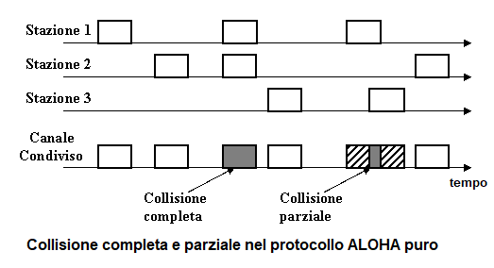
Figure: Pure ALOHA - collisions

A more advanced version of the protocol, called "slotted ALOHA", provides that the transmission takes place at precise time intervals ("slots") lasting the duration of a packet.
Each station is bound to begin its transmission at the beginning of a time slot.
In this case, the communication vulnerability period is equal to the duration of a single packet because the packets completely overlap or no collision occurs.
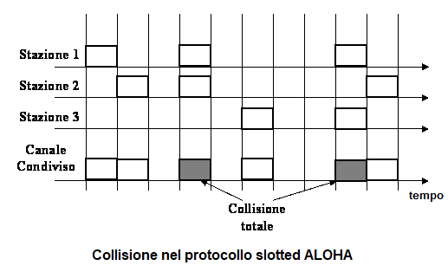
Figure: Slotted ALOHA – collision

This halves the likelihood of collisions and increases the efficiency of communication.
The realization of a "slotted ALOHA" shared access, however, requires a synchronization between stations, impossible to achieve with the hardware available for the amateur packet radio; for this reason, in the following we aim to evaluate how the pure ALOHA protocol influences the performance of communications on a shared channel without taking into consideration the slotted ALOHA access.

So let's imagine having a shared communication channel in which numerous stations send packets all of the same length randomly with the same signal level, without worrying about listening if the channel is idle (“pure ALOHA” access protocol to the shared medium).
Let’s indicate with G the fraction of the channel capacity committed by traffic (normalized traffic) and with S the quantity of information successfully transmitted referring to the overall channel capacity (normalized throughput).
Theoretical studies show that, for such access to the shared channel, the normalized throughput S depends on the normalized traffic G according to the relationship

S = G e^{-2G}

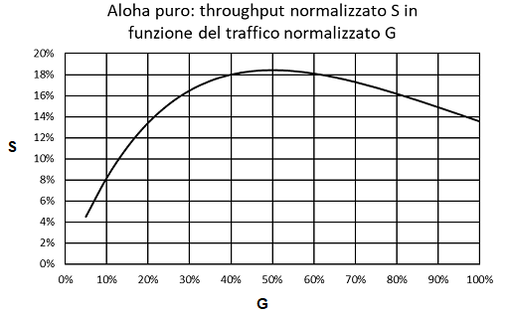
Figure: Pure ALOHA - throughput S as a function of traffic G

The maximum throughput is 18.4% of the total channel capacity at 50% of channel use (G = 0.5); in these conditions the maximum percentage of packets received successfully is equal to 36.8% of the total traffic generated. If the traffic exceeds 50% of the overall transmission channel capacity, not only does the throughput decrease, but the network becomes unstable and the communications collapse. To increase the probability of successfully transmitting packets it is necessary to reduce the load on the channel.
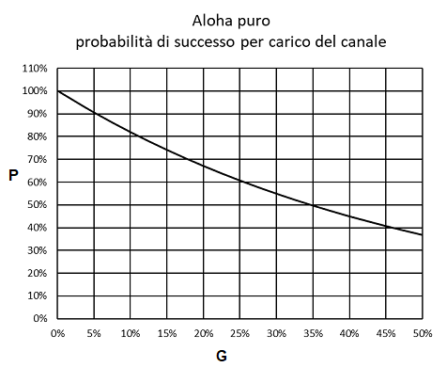
Figure: Pure ALOHA – Chance of success as a function of traffic G

In the packet radio context, the situation we have described above occurs when a certain number of terminals, which do not listen to each other (and therefore their collision control mechanism is ineffective), randomly transmit frames to a privileged station, which listens to all terminals.
Typically this occurred for conventional packet radio satellites that hosted a BBS (e.g. pacsat-AO16). These satellites had uplink channels dedicated to listening to terrestrial stations - which due to the great mutual distance did not listen to each other and could not operate any collision check - and a broadcast-type downlink channel.
Referring to the overall capacity of an APRS network cycle calculated previously (900 frames / cycle) it is possible to estimate the number of frames successfully receivable from the privileged station according to the load of the channel in a situation of this type:

Load | Throu-ghput | Colli-sions | Idle |  | Chance of  success |  | Frames sent | Frames success-fully received
G | S | C=G-S | I=1-G |  | P = S/G |  | fr/  cycle | fr/  cycle
0% | 0,0% | 0,0% | 100,0% |  | 100,0% |  | 0 | 0
5% | 4,5% | 0,5% | 95,0% |  | 90,5% |  | 45 | 41
10% | 8,2% | 1,8% | 90,0% |  | 81,9% |  | 90 | 74
15% | 11,1% | 3,9% | 85,0% |  | 74,1% |  | 135 | 100
20% | 13,4% | 6,6% | 80,0% |  | 67,0% |  | 180 | 121
25% | 15,2% | 9,8% | 75,0% |  | 60,7% |  | 225 | 136
30% | 16,5% | 13,5% | 70,0% |  | 54,9% |  | 270 | 148
35% | 17,4% | 17,6% | 65,0% |  | 49,7% |  | 315 | 156
40% | 18,0% | 22,0% | 60,0% |  | 44,9% |  | 360 | 162
45% | 18,3% | 26,7% | 55,0% |  | 40,7% |  | 405 | 165
50% | 18,4% | 31,6% | 50,0% |  | 36,8% |  | 450 | 166

We observe that in the situation of maximum possible channel load (G = 50%) we will be able to transmit 450 frames per network cycle, of which however only 36.8% (166 frames) will be correctly received by the privileged station and almost 2/3 lost in collisions, making communication unreliable.
By reducing the network load to 15% of the channel capacity, corresponding to 135 frames transmitted per network cycle, 100 frames will be received successfully. The probability of success of communication to the privileged station will now be 74.1%.

Assuming that the mobile APRS stations on the network are about half of the fixed stations, a total of 57 stations (19 mobile that transmit a frame every 5 minutes and 40 fixed that transmit a frame every 20 minutes) will be able to transmit with good probability of success to the privileged listening station.
The situation described, which does not currently occur in the APRS network, is a useful starting point for evaluating the performance of more complex situations that we will discuss later.

2.3 CSMA: listen before transmitting
CSMA (Carrier Sense Multiple Access) is a method of access control to the shared channel of the distributed type in which the channel traffic carries information on the control of its flow.
It was introduced in 1971 for use in packet radio channels and subsequently was also used in wired networks, in particular in ethernet networks in the CSMA / CD version.
You listen to the channel before transmitting; if the channel is idle, an algorithm is executed that decides when to transmit.

There are three versions of the protocol that are distinguished by the decision algorithm:

• non-persistent CSMA: listen to the channel before transmitting; if it is idle, transmit, if it is busy, wait for a random interval and try again.
• p-persistent CSMA: listen to the channel before transmitting; if it is busy, wait, if it is idle, transmit with probability "p".
• 1-persistent CSMA: listen to the channel before transmitting; if it is idle, transmit, if it is busy, wait for it to be idle and transmit.

In the TNCs used for packet radio the 1-persistent version is common, used in particular for digipeating, and is also supported the more elaborate p-persistent version which, although more efficient, is rarely used because in order to function correctly it requires that all stations set the same parameters that define the transmission probability.

An important parameter that affects the performance of all versions of the CSMA protocol is the collision window "a", caused by the delay in information propagation, defined by the relationship:
a = tp / tf
in which "tp" is the information propagation time and "tf" the duration of a packet.

Referring to the 1-persistent version, in the literature it is found that the throughput S depends only on the normalized traffic G and the amplitude of the collision window, and is given by:

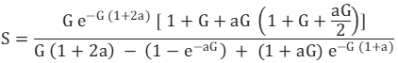

If the window "a" is sufficiently small (propagation time much less than the duration of the packet, a = 0) the previous relationship is simplified in:

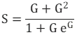
As the amplitude of the collision window "a" increases, the performance decreases until it becomes comparable with the performance of the pure ALOHA protocol for a> 0.5

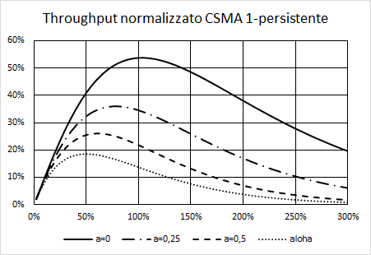
Figure: throughput S as a function of traffic G for different values of "a" and comparison with ALOHA

G | a=0 | a=0,25 | a=0,5 | a=0,75 | Pure ALOHA
2% | 2,0% | 2,0% | 2,0% | 1,9% | 1,9%
10% | 9,9% | 9,4% | 9,0% | 8,5% | 8,2%
20% | 19,3% | 17,5% | 15,9% | 14,4% | 13,4%
30% | 27,8% | 24,0% | 20,8% | 18,0% | 16,5%
40% | 35,1% | 28,9% | 23,9% | 19,8% | 18,0%
50% | 41,1% | 32,4% | 25,6% | 20,2% | 18,4%
60% | 45,9% | 34,6% | 26,1% | 19,7% | 18,1%
70% | 49,4% | 35,7% | 25,8% | 18,6% | 17,3%
80% | 51,8% | 36,0% | 24,8% | 17,0% | 16,2%
90% | 53,2% | 35,5% | 23,4% | 15,4% | 14,9%
100% | 53,8% | 34,5% | 21,8% | 13,6% | 13,5%

Table: throughput S as a function of traffic G for different values of "a" and comparison with ALOHA

In the case of 1200 bps amateur radio packet communications that use FM voice communication devices, the average duration of the transmission of a previously estimated packet is equal to 1.33s, while the information propagation time is dominated by the switching time of the apparatuses and can be estimated at 0.3s; the collision window will then be

a = 0,3 / 1,33 = 0,23

resulting in a maximum throughput of 36% for total traffic offered G = 80%.

The probability of successful transmission is not very high (P = 36/80 = 45%); to increase the reliability of communications to 72% it is necessary to halve the traffic offered (G = 40%) with a significant reduction in throughput (S = 28.9%).

Despite this, in a network cycle of 20 minutes, 360 frames can be transmitted with good chance of success, equal to 144 stations, 72 mobile that transmit a frame every 5 minutes and 72 fixed that transmit a frame every 20 minutes.
The stations, however, should all listen to each other, which is highly unlikely given their radio horizon (on the plain, on average 5 km for a mobile station, 10 km for a fixed station).

CHAPTER 3
APRS networks with a single digipeater

3.1 APRS network with a single isofrequency digipeater
Now let’s imagine that there is only one digipeater on the network that listens to all stations with the same signal level (exposed terminal) and repeats the correctly received packets.
The stations on the network do not listen to each other (hidden terminals) but all listen to the digipeater, and transmit their packets randomly when they detect the channel to be idle, that is when the digipeater does not transmit.
On the contrary, when the digipeater is transmitting, no packets are emitted by the terminals.
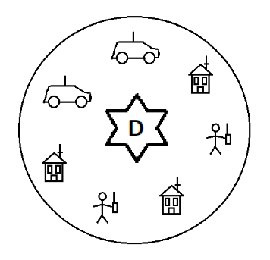

We can think the network cycle as logically divided into two time slots, one used for the generation of traffic by network terminals with pure ALOHA protocol, which we could call “uplink slot”, and one used for the repetition of the valid packets received by the digipeater with 1-persistent CSMA protocol, which we could call the “downlink slot”.
Suppose for simplicity that the collision window of the CSMA 1-persistent protocol is very small, so that at low network loads all the throughput of the uplink slot is repeated without collisions.
Referring to the uplink slot and indicating with G the normalized traffic, we will have that throughput "S", collisions "C", inactivity factor "I" and transmissions chance of success "P" can be calculated with the previous expressions referring to a pure ALOHA channel.
But since all the throughput of the uplink slot is repeated by the digipeater, the overall capacity "K" of the channel referred to the uplink slot is

K = 1 + S = 1 + G e^{-2G}

To calculate the traffic expressions of the uplink slot Gk, the throughput Sk, the collisions Ck and the fraction of idle channel Ik according to the traffic in the uplink slot G normalized with respect to the overall capacity of the channel, it is sufficient to renormalize G, S, C and I compared to K

Gk = G / K = G / (1 + G e^{-2G} )
Sk = S / K = G e^{-2G} / (1+ G e^{-2G} )
Ck = G (1 – e^{-2G} ) / (1+ G e^{-2G} )
Ik = ( 1 – G ) / (1 + G e^{-2G} )

Let us represent also in this case the normalized throughput Sk with respect to the normalized traffic Gk and compare it with the throughput graph of the previous case (shared channel with pure ALOHA protocol access without digipeater):

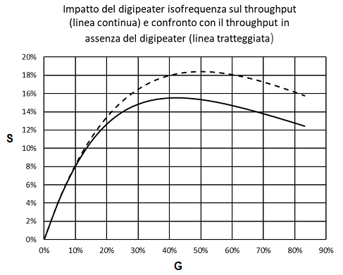
Figure: impact of the isofrequency digipeater on throughput (solid line)
and comparison with throughput without digipeater (dashed line)
We observe that, as expected, the throughput is always lower than in the case of pure ALOHA in the absence of digipeater, and the maximum throughput Sk, max = 15,5% occurs at a lower channel load (Gk = 42.2% ), being a part of the channel capacity engaged in digipeating.
With the same normalized traffic, the chance of transmission success also decreases, especially when the traffic in the channel is heavy.

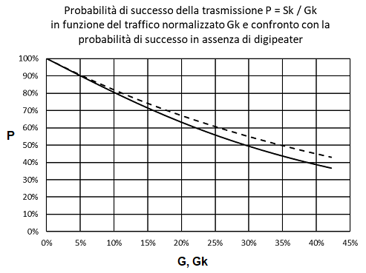
Figure: Chance of success P=Sk / Gk according to the normalized traffic Gk
and comparison with the chance of success without a digipeater

Uplink slot load |  | Norma-lized  traffic | Norma-lized throu-ghput | Norma-lized  Colli-sions | Channel fraction used for digipeating | Channel fraction not used |  | Chance of success
G |  | Gk | Sk | Ck | Rk | Ik |  | P = Sk/Gk
0% |  | 0,0% | 0,0% | 0,0% | 0,0% | 100,0% |  | 100,0%
5% |  | 4,8% | 4,3% | 0,5% | 4,3% | 90,9% |  | 90,5%
10% |  | 9,2% | 7,6% | 1,7% | 7,6% | 83,2% |  | 81,9%
15% |  | 13,5% | 10,0% | 3,5% | 10,0% | 76,5% |  | 74,1%
20% |  | 17,6% | 11,8% | 5,8% | 11,8% | 70,5% |  | 67,0%
25% |  | 21,7% | 13,2% | 8,5% | 13,2% | 65,1% |  | 60,7%
30% |  | 25,8% | 14,1% | 11,6% | 14,1% | 60,1% |  | 54,9%
35% |  | 29,8% | 14,8% | 15,0% | 14,8% | 55,4% |  | 49,7%
40% |  | 33,9% | 15,2% | 18,7% | 15,2% | 50,9% |  | 44,9%
45% |  | 38,0% | 15,5% | 22,6% | 15,5% | 46,5% |  | 40,7%
50% |  | 42,2% | 15,5% | 26,7% | 15,5% | 42,2% |  | 36,8%

Table: Distribution of channel use according to the traffic offered and chance of transmission success - network with a single isofrequency digipeater

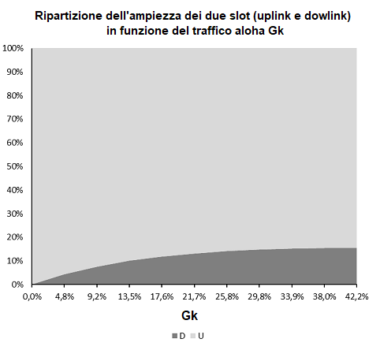
Figure: Distribution of the uplink and downlink slot according to aloha traffic Gk

Normalized load | Width of the downlink slot | Width of the uplink slot
Gk | D | U
0,0% | 0,0% | 100,0%
4,8% | 4,3% | 95,7%
9,2% | 7,6% | 92,4%
13,5% | 10,0% | 90,0%
17,6% | 11,8% | 88,2%
21,7% | 13,2% | 86,8%
25,8% | 14,1% | 85,9%
29,8% | 14,8% | 85,2%
33,9% | 15,2% | 84,8%
38,0% | 15,5% | 84,5%
42,2% | 15,5% | 84,5%

When the load of the network is reduced, however, the introduction of the digipeater on the channel slightly worsens throughput and chance of success compared to the situation without a digipeater, because decreasing the offered traffic reduces also the use of the channel for digipeating, and consequently increases the width of the uplink slot.
Referring to the overall capacity of the network cycle previously calculated (900 frames / cycle) it is possible to estimate also in this case the number of frames received successfully according to the network load.
Norma-lized traffic | Chance of success |  | Frames transmitted per network cycle | Frames  received per network cycle
Gk | P = Sk/Gk |  | fr/cycle | fr/cycle
0,0% | 100,0% |  | 0 | 0
4,8% | 90,5% |  | 43 | 39
9,2% | 81,9% |  | 83 | 68
13,5% | 74,1% |  | 121 | 90
17,6% | 67,0% |  | 159 | 106
21,7% | 60,7% |  | 195 | 119
25,8% | 54,9% |  | 232 | 127
29,8% | 49,7% |  | 268 | 133
33,9% | 44,9% |  | 305 | 137
38,0% | 40,7% |  | 342 | 139
42,2% | 36,8% |  | 380 | 140

Table: APRS frames successfully received according on the traffic offered
- network with a single isofrequency digipeater

In the situation of maximum possible channel load (Gk = 42.2%) we will be able to transmit 380 frames per network cycle of which, however, only 36.8% (140 frames) will be correctly received and repeated by the digipeater and almost 2 / 3 lost in collisions, making the communication unreliable.
By reducing the network load to 13.5%, corresponding to 121 frames transmitted by the APRS terminals per network cycle, as many as 90 frames will be successfully received and repeated, increasing the reliability of communication to 74.1% (only 1/4 of the packets transmitted will be lost in collisions).

Assuming also in this case that mobile stations in the network are about half of the fixed stations, we will be able to serve 53 stations with high probability of success, 17 mobile stations that transmit a frame every 5 minutes and 36 fixed stations that transmit a frame every 20 minutes, performances that do not differ much from those of an ALOHA channel without digipeater.

Therefore, in the case of an APRS network with a single digipeater, it is not justified to use separate frequencies for the uplink and downlink, because the throughput improvements would be moderate at the cost of an increase in terminals and digipeater complexity (they should be able to operate simultaneously on two different frequencies and should be equipped with two TNCs).

3.2 More efficiency: one digipeater, multiple uplink channels
A classic solution to increase the throughput of a single digipeater network is to use multiple uplink channels - for example in UHF -, to which the terminals access with the ALOHA protocol, and a separate downlink channel - for example in VHF - received by all stations, on which the digipeater repeats the overall throughput of the uplink channels, possibly in a redundant way and / or integrated by other information on the state of the network.
Since the maximum throughput for each uplink channel is 18.4% of its overall capacity, a single downlink channel could theoretically serve up to 5 uplink channels at the same speed, (100 / 18.4 = 5.43 ) and the maximum througput on the downlink channel could reach 92% of the channel capacity (18.4% * 5 = 92%).
In order to transmit information redundantly, however, it seems appropriate to reduce the maximum number of uplink channels to 4, with a corresponding overall maximum throughput of 73.6% (18.4% * 4 = 73.6%).
Also in this case, to ensure a high probability of communication success, you must significantly reduce the load for each uplink channel:

Traffic on 1 uplink channel | Through-put for 1 uplink channel | Total through  -put (4 channels) |  | Chance of success |  | Frames sent | Frames received
G | S | 4 S |  | P |  | fr/cycle | fr/cycle
5,0% | 4,5% | 18,1% |  | 90,5% |  | 180 | 163
10,0% | 8,2% | 32,7% |  | 81,9% |  | 360 | 295
15,0% | 11,1% | 44,4% |  | 74,1% |  | 540 | 400
20,0% | 13,4% | 53,6% |  | 67,0% |  | 720 | 483
25,0% | 15,2% | 60,7% |  | 60,7% |  | 900 | 546
30,0% | 16,5% | 65,9% |  | 54,9% |  | 1080 | 593
35,0% | 17,4% | 69,5% |  | 49,7% |  | 1260 | 626
40,0% | 18,0% | 71,9% |  | 44,9% |  | 1440 | 647
45,0% | 18,3% | 73,2% |  | 40,7% |  | 1620 | 659
50,0% | 18,4% | 73,6% |  | 36,8% |  | 1800 | 662

Table: APRS frames successfully received according to the traffic offered and chance of success – single digipeater network with multiple uplink channels and a separate downlink channel

For a load of the single uplink channel of 15%, corresponding to 135 frames transmitted per network cycle on each uplink channel (540 total frames), 400 frames will be flawlessly received with a high probability of success (74.1%).
Assuming also in this case that the mobile stations in the network are about half of the fixed stations, we will be able to transmit with a high chance of success 228 stations, 78 mobile that transmit a frame every 5 minutes and 150 fixed that transmit a frame every 20 minutes, provided that the traffic is distributed equally across the four uplink channels.
To evenly distribute the stations among the four channels, rules could be established based -for example- on the letters of the callsign, on the nature of the stations (distinguishing between fixed and mobile stations) or it could be the same digipeater, depending on traffic conditions, to suggest some stations to move to another less busy channel.
Such a configuration could successfully serve a very large or very congested geographical area using a single digipeater, at the expense of an increase in complexity and cost of the terminal stations, which should be equipped with two apparatuses, one for UHF transmission and one for reception in VHF (or a dual band transceiver), and two TNCs. The digipeater should be much more complex, equipped with: four VHF receivers tuned to the four uplink channels, four TNCs for reception, a VHF transmitter, a TNC for repeating received packets and dedicated software.

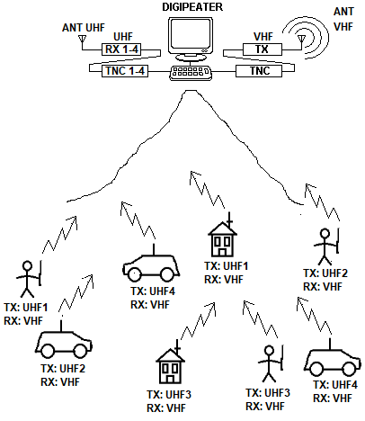
To reduce at least the complexity of the terminal stations, it is possible to think of compromise solutions that, in exchange for lower performance, allow network clients for the use of single band equipment and / or a single TNC.
Referring to the configuration just described, in fact, it is not strictly necessary that APRS terminals use two separate TNCs, one for transmission and one for reception: taking advantage that the transmission of each terminal station is bursty, a single TNC could be used by disabling the CSMA access control and agreeing not to listen during the short time interval in which the transmission of the APRS packet takes place (1.33 seconds).
The reception of the information could however be guaranteed by the redundancy of the digipeater transmission.
The uplink channels and the downlink channel could then be allocated on the same band, for example in VHF, so that the terminal stations could use single-band equipment.
In particular, by using only two uplink channels shifted by +600kHz and -600kHz with respect to the frequency of the downlink channel, you could exploit the standard offsets of the analog equipment currently used by the radio amateurs.
In this way the performance would be about half of the previously calculated one but no modification of the terminal stations would be required, only the activation of the standard offsets for accessing the analog voice repeaters.
Also in this case, rules could be established to distribute the stations among the two uplink channels: the possibility to allocate one frequency for the fixed stations and the other for the mobile stations appears interesting.
However, this solution would force to install resonant cavities on the digipeater to obtain the necessary selectivity, further increasing its complexity, cost and size.

3.3 APRS network with an analog repeater?
The AFSK modulation, very inefficient and used in low speed packet radio communications (1200 bps) to allow the reuse of normal analog FM radio equipment for voice communications, allows at least in theory the use of a conventional analog repeater for repetition of packets.
The main advantage of this solution is that, in such a similar configuration, the problem of the hidden terminal no longer exists: given that all the stations listen to each other in real time via the analog repeater, the CSMA mechanism of shared channel access (carrier detection) installed in the terminal TNCs is effective. Another advantage is the absence of delay in the propagation of the information: the network terminals immediately listen to the repeated packets as they are generated, having the feeling to be connected to a network which, despite the low transmission rate, responds promptly, making it possible to exchange messages and bulletins in real time.
The idea is almost as old as packet radio: an old document by D. Engle, KE6ZE, entitled "Packet radio timing considerations", examined the performance of three different connection modes, direct, through an analog repeater and through a conventional digipeater, concluding that the use of an analog repeater is more efficient than conventional digipeating.
The author conducted experiments on a standard voice repeater with a transmission delay of 500ms. A few years later (1987) R. Finch and S.Avent, in another document "A duplex packet radio repeater approach to layer one efficiency", resumed and perfected the idea, highlighting how a sufficiently fast turn-around was the key to an essentially transparent operation, as well as the cleanest possible audio chain to reduce the number of errors, proposing the use of special repeaters instead of the reuse of FM voice repeaters, they say - and not wrongly - inadequate.
If we imagine in fact to use conventional FM repeaters, the switching / activation times of the transmitters are at least double compared to direct communication, and the size of the collision window of the CSMA protocol is at least double compared to that calculated in the previous chapter (a = 0.46 instead of a = 0.23). For such an amplitude of the collision window the theoretical calculations indicate a maximum throughput S = 26% for normalized traffic G = 60% (reliability 43.3%), performance not much higher than that of an ALOHA channel; if we add that the AFSK signal degrades passing through the repeater - and therefore increases the probability of errors - the gap between the two solutions is further reduced. At low loads, necessary to have more reliable communications, the gap between the solutions becomes negligible:

 | Offered traffic G | Throu-ghput S | Chance of success
1-persist CSMA(a=0,5,analog repeater) (*) | 20% | 15,9% | 79%
ALOHA (up/downlink on separate channels) | 20% | 13,4% | 67%
ALOHA + isofrequency digipeating | 20% | 12,5% | 64%
(*) the degradation of the signal introduced by the analog repeater is neglected

In conclusion, the use of an analog repeater can be a valid solution for the creation of an APRS network, provided that the switching times of the repeater are very short and that the repeater distorts the signal as little as possible.
The greatest advantages are with heavy traffic; when the network is lightly loaded, the performance is not much higher than conventional solutions.

CHAPTER 4
Performance and limitations of the current APRS network

4.1 Impact of multiple digipeaters on an isofrequency network
The results we reached in the previous chapter refer to a network in which terminals do not listen to each other and access randomly the shared radio channel and in which operates only one digipeater which listens to all the stations.
Let us now try to evaluate the impact on the local throughput of the presence of adjacent digipeaters operating on the same frequency that listen to each other, making multiple digipeating possible (which however is a discouraged practice).
For simplicity we consider the case in which each digipeater listens and serves only the terminals of its area, that multiple digipeating does not occur and that the use of bandwidth for the repetition of the packets by the digipeaters is negligible compared to the overall capacity of the channel, confusing for each digipeater the uplink slot with the entire channel.
By indicating with G the total traffic in the uplink slot of each digipeater, the overall throughput S in the uplink slot of each digipeater will be equal to

S = G e ^{-2 G}

But of all the throughput of the uplink slot we are concerned only with the useful fraction produced by the local traffic; if we imagine that the proportion between useful fraction of throughput "SL" and overall throughput "S" is the same as that between local useful traffic "GL" and overall traffic "G" we will have that:
S_{L}= S (G_{L} / G)

By indicating with N the number of adjacent interfering digipeaters, with "SL" the traffic repeated by them - which, since multiple digipeating does not occur, is configured as an ALOHA disturbance in the local uplink slot - and with GL the normalized traffic in the uplink slot produced from local stations only, we will have that total traffic "G" in the uplink slot will be

G = G_{L} + N S_{L}
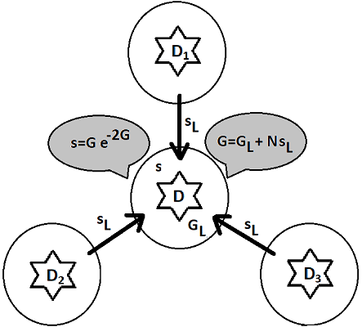
Figure: impact of adjacent digipeaters on the uplink slot of the central digipeater: only the GL fraction of the traffic of the upload slot is generated by the local terminals, the rest is disturbance (Ns_{L}); throughput depends on overall traffic G (local traffic + noise).

By combining the two previous relationships we will have:

S_{L} = (G_{L} / G) G e ^{-2 G}

Simplifying for G and expressing GL as a function of G:

S_{L} = (G – N S_{L}) e ^{-2 G}

and developing the calculations we will get

S_{L} / (G – N S_{L}) = e ^{-2 G}

(G – N S_{L}) / S_{L} = e ^{2 G}

(G / S_{L}) – N = e ^{2 G}

G / S_{L} = e ^{2 G} + N

S_{L} / G = 1 / (e ^{2 G} + N)

S_{L} = G / (e ^{2 G} + N)

The relation obtained allows to calculate the useful throughput fraction SL as a function of traffic G and has significance for values of G <0.5.

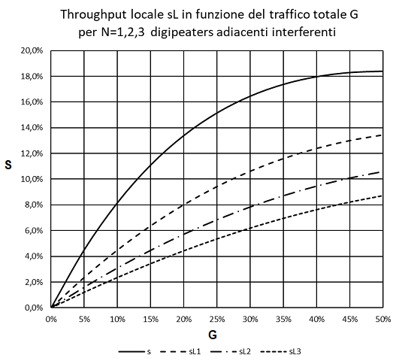
Figure: Local (useful) throughput sL according to the overall traffic G for N=1,2,3 interfering digipeaters

Total traffic uplink slot | Total Throu-ghput | Local throughput (useful) |  |  |  | Chance of success
 |  | 1 Interfe-ring digi | 2 Interfe-ring digis | 3 Interfe-ring digis
G | S | SL1 | SL2 | SL3 |  | P
0% | 0,0% | 0,0% | 0,0% | 0,0% |  | 100,0%
5% | 4,5% | 2,4% | 1,6% | 1,2% |  | 90,5%
10% | 8,2% | 4,5% | 3,1% | 2,4% |  | 81,9%
15% | 11,1% | 6,4% | 4,5% | 3,4% |  | 74,1%
20% | 13,4% | 8,0% | 5,7% | 4,5% |  | 67,0%
25% | 15,2% | 9,4% | 6,9% | 5,4% |  | 60,7%
30% | 16,5% | 10,6% | 7,8% | 6,2% |  | 54,9%
35% | 17,4% | 11,6% | 8,7% | 7,0% |  | 49,7%
40% | 18,0% | 12,4% | 9,5% | 7,7% |  | 44,9%
45% | 18,3% | 13,0% | 10,1% | 8,2% |  | 40,7%
50% | 18,4% | 13,4% | 10,6% | 8,7% |  | 36,8%

Table: Local throughput as a function of total offered traffic with 1,2,3 interfering digipeaters

Remembering that SL = S (GL / G), we can derive the corresponding local traffic GL = (SL / S) G, which allows us to estimate the maximum number of useful frames that can be transmitted in the local uplink slot per network cycle, and therefore the maximum number of stations that each digipeater can serve.
Total traffic uplink slot | Local traffic (useful) |  |  |  | Local frames transmitted per network cycle
 | 1 Interfe-ring digi | 2 Interfe-ring digis | 3 Interfe-ring digis |  | 1 Interfe-ring digi | 2 Interfe-ring digis | 3 Interfe-ring digis
G | GL1 | GL2 | GL3 |  | fr/  cycle | fr/  cycle | fr/  cycle
0% | 0,0% | 0,0% | 0,0% |  | 0 | 0 | 0
5% | 2,6% | 1,8% | 1,3% |  | 24 | 16 | 12
10% | 5,5% | 3,8% | 2,9% |  | 49 | 34 | 26
15% | 8,6% | 6,0% | 4,7% |  | 78 | 54 | 42
20% | 12,0% | 8,5% | 6,6% |  | 108 | 77 | 60
25% | 15,6% | 11,3% | 8,9% |  | 140 | 102 | 80
30% | 19,4% | 14,3% | 11,3% |  | 174 | 129 | 102
35% | 23,4% | 17,6% | 14,1% |  | 210 | 158 | 127
40% | 27,6% | 21,1% | 17,0% |  | 248 | 190 | 153
45% | 32,0% | 24,8% | 20,3% |  | 288 | 223 | 182
50% | 36,6% | 28,8% | 23,8% |  | 329 | 259 | 214

Table: locally transmissible frames with 1,2,3 interfering digipeaters
Referring to the case of three adjacent interfering digipeaters, in the situation of maximum possible load of the uplink slot (G = 50%) we will be able to transmit 214 frames per network cycle, of which however only 36.8% (79 frames) will be correctly received and repeated by the local digipeater and almost 2/3 lost in collisions, making communication unreliable.
By reducing the load on the network in the uplink slot to 15%, corresponding to 42 frames transmitted by the local APRS terminals per network cycle, the reliability of communication will increase to 74.1% and it will be possible to successfully receive and repeat 31 frames per cycle 20-minute network, i.e. 1 frame every 39 seconds. Assuming also in this case that the mobile stations in the network are about half of the fixed stations, each digipeater in a 20-minute network cycle can serve with high chance of success only 21 stations, 7 mobile stations that transmit a frame every 5 minutes and 14 fixed stations that transmit a frame every 20 minutes. We observe how the presence of adjacent digipeaters on the same channel heavily penalizes local throughput.

4.2 Multiple Digipeating
Now suppose that, in the scenario outlined, a station - which constitutes an exception - sends a frame requesting to be repeated by multiple digipeaters. We ask ourselves: what is the probability of the packet reaching at its destination by successfully spreading over the network?
Let's initially consider the case of the propagation of the packet in a chain of adjacent repeaters, each serving its own “cell”. A packet propagating in a chain of N adjacent repeaters will be subject to ALOHA statistics N times; in particular, the chance that it is correctly repeated through the chain will be the product of the probabilities that it has to successfully pass through every single digipeater.
Assuming that all repeaters are identical and are in the same load conditions G, and indicating with P the probability that a packet is correctly repeated by a digipeater - which depends on the load G of the cell itself -, we will have the probability PN that the packet has to successfully pass through the whole chain of digipeaters will be
P_{N}(G)= [P(G)]^{N}

Total traffic  G | Chance of success of the transmission
 | 1 repe-tition  (local)) | 2  Repe-titions | 3  Repet-itions | 4  Repe-titions
0% | 100,0% | 100,0% | 100,0% | 100,0%
5% | 90,5% | 81,9% | 74,1% | 67,0%
10% | 81,9% | 67,0% | 54,9% | 44,9%
15% | 74,1% | 54,9% | 40,7% | 30,1%
20% | 67,0% | 44,9% | 30,1% | 20,2%
25% | 60,7% | 36,8% | 22,3% | 13,5%
30% | 54,9% | 30,1% | 16,5% | 9,1%
35% | 49,7% | 24,7% | 12,2% | 6,1%
40% | 44,9% | 20,2% | 9,1% | 4,1%
45% | 40,7% | 16,5% | 6,7% | 2,7%
50% | 36,8% | 13,5% | 5,0% | 1,8%

Table: Chance of successful transmission in the case of a sequence of multiple repetitions

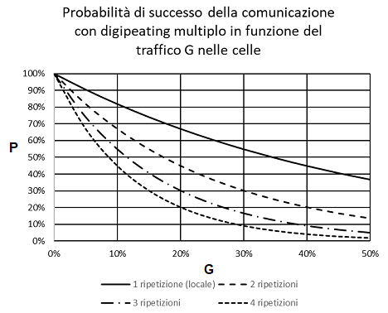
Figure: Chance of successful transmission in the case of a sequence of multiple repetitions according to the traffic G in the cells

The probability that the packet arrives at its destination therefore depends both on the load of the cells “G” and on the number of N cells that the packet must go through to arrive at its destination.
In the situation of maximum possible load of the cells (G = 50%, corresponding to 23.8% of useful traffic considering for each digipeater the disturbance caused by three other interfering digipeaters) the packet can reach the adjacent cell with a probability of 13.5% , and the next with probability 5%.
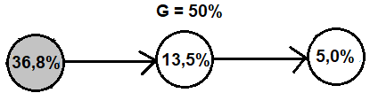
P = 0,368 x 0,368 x 0,368 = 0,05 = 5,0%

By reducing the load of the network in the cells to 15%, (corresponding to 4.7% of useful traffic) the chance to reach the adjacent cell will increase to 54.9%, and the immediately following one will be 40.7%.
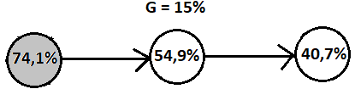
P = 0,741 x 0,741 x 0,741 = 0,407 = 40,7%

If, to reach the recipient, the repeated packet travels several paths, the probability of success is greater because communication becomes redundant; remembering that the reliability of a redundant system R is given by
R = 1 – (1 - R₁) (1 - R₂)…..(1 - R_{N}) ,

in the maximum load situation of the cells (G = 50%, GL = 23.8% with 3 interfering digipeaters), referring to the figure below and remembering that the digipeaters are all identical and loaded the same way, the overall reliability (chance of success) of the communication from the leftmost cell to the rightmost cell (from sender to recipient) can be calculated as follows:
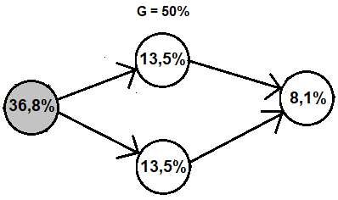
P = 0,368 x [1 – (1 – 0,368)²] x 0,368 =
= 0,368 x 0,601 x 0,368=
= 0,081 = 8,1%

In the same situation, reducing the overall load of the cells to 15% (GL = 4.7% with 3 interfering digipeaters) the overall reliability of communication will increase to 51.2%.
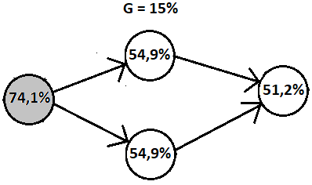
P = 0,741 x [1 – (1 – 0,741)²] x 0,741 =
= 0,741 x 0,933 x 0,741=
= 0,512 = 51,2%

We observe, as we expected again, that multiple digipeating has a fair chance of success only if the network load is very low.

CHAPTER 5
New possible arrangements

5.1 Foreword
The simplified analysis of the functioning of the APRS network made in the previous chapters suggests that the weak point of the current network is the interference that the uplink slot of each cell undergoes from adjacent digipeaters. Researching new configurations that do not suffer from this problem, we cannot ignore the need for reuse of existing equipment (radio and TNC), possibly without the need to make changes: it is very difficult to think that users will invest time and economic resources in a technology outdated as is the packet radio. The solutions proposed in this chapter try to circumvent the problem by giving up the constraint of a completely isofrequency network without increasing too much - or not increasing at all - the complexity of terminal stations and repeaters.

5.2 A minimally invasive intervention: add a listening channel
A non-invasive intervention would consists in equipping the existing digipeaters with a UHF only listening port, to be used as an additional uplink port, leaving the operation of the isofrequency network in VHF unchanged.
Terminal stations could access the network in two ways:
- isofrequency in VHF, using a VHF radio and a TNC as now;
- transmitting in UHF and receiving in VHF, using a dual band transceiver and a single TNC, disabling the CSMA access mechanism to the shared channel.
In this way, the traffic repeated by the digipeaters would no longer congest the UHF uplink channel, which for each cell could always be used to its maximum capacity for ALOHA access (G = 50%, S=18%). Stations that did not wish (or could not) adapt to the new access method would continue to access the APRS network isofrequency in VHF as before.
This solution is interesting because it would allow a gradual transition to the new configuration.

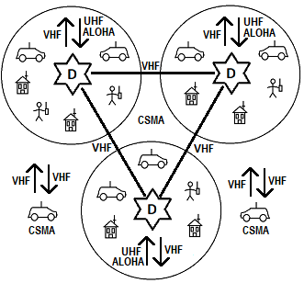
Figure: terminal stations transmit in UHF, digipeating occurs in VHF. Stations wishing to access the network as before, isofrequency in VHF, can continue to do so.

However, it should be emphasized that the improvement of the uplink performance, however strategic given the weak power of the terminal stations, causes a greater saturation of the VHF network with negative outcomes on communications between the digipeaters.
In addition, stations that transmit in UHF must accept the loss of information caused by the fact that they cannot listen to the downlink channel in VHF when they transmit.
However, as we said before, this loss is very limited and is not a serious problem because the transmission of packets is bursty.

5.3 Greater efficiency: a network articulated into two levels
A more efficient solution is to articulate the network into two different hierarchical levels, a lower level (LAN) in which local traffic is processed, and a higher level in which interconnection between cells (WAN) takes place.
Operationally, the network can be fragmented into many independent cells operating at different frequencies (for example in UHF), each served by its own digipeater.
The interconnection between the cells (WAN), which makes multiple digipeating possible, can take place on a separate frequency, for example in VHF.
The terminal stations would operate isofrequency in UHF with the usual hardware and software; only the digipeater would be more complex, having to be equipped with two TNCs, one for the management of the belonging cell, combined with a UHF transceiver, the other to communicate with the other digipeaters, combined with a VHF transceiver.

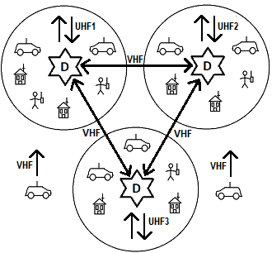

Figure: the network, completely via radio, divided into independent UHF cells and interconnected in VHF. Some stations, which only want to be tracked, can access the network in VHF.

In this configuration, traffic between digipeaters (data transfer between different cells) does not interfere with local traffic either in uplink or downlink: the APRS stations listen only to their own digipeater and are not disturbed either by the stations or by the digipeaters of the neighboring cells.
Within each cell, throughput can reach 15.5% of the transmission channel capacity for a traffic equal to 42.2% of the total channel capacity.
Adjacent cells operate on different UHF frequencies so as not to interfere with each other, but the reuse of frequencies can occur for cells far enough away that they do not listen to each other.
At the upper hierarchical level (WAN), traffic between digipeaters is reduced to only the packets for which multiple digipeating is required, with great benefit for the entire network (both throughput and reliability of communications).
The diffusion of information within the network takes place as follows: packets transmitted with the WIDE1-1 path remain confined within their cell, packets for which a wider diffusion is required are instead repeated in VHF by progressively decreasing the counter of repetitions and retransmitted in UHF in the transit cells, until the counter is reset.
Mobile stations that move from one cell to another and only need to be tracked (without having to be contacted) can forward their signal directly in VHF to the upper hierarchical level; in this way they do not need to frequently retune and have the additional advantage of finding a much less busy VHF channel because it is free from the local traffic, managed in UHF within the individual cells.
Once they reach their destination, they can tune into the UHF frequency of the arrival cell and participate in two-way communications.

5.4 IGATES: widespread listening and broadcasting
As we observed in the introduction, the internet currently plays an important role in routing APRS packets. For strategic reasons, however, the network remains potentially able to operate exclusively via radio by relying on digipeaters.
If you give up potential independence from the web and agree to use exclusively the internet for the collection and routing of the packets, you can easily create a particularly efficient configuration of the APRS network with the available hardware that we could define as "widespread listening and broadcasting".
The reception of the packets transmitted by the APRS stations would be carried out by numerous exclusively receiving IGATE stations scattered throughout the territory, which would create a widespread listening isofrequency network.
The APRS-IS network would act as a collector for all packets received, routing the data to other exclusively transmitting IGATE stations which would broadcast the packets of local interest on a different frequency.
In this configuration isofrequency digipeaters, which as we have seen are the main cause of the degradation of the performance of the APRS network, would not be used at all.

The advantages would be numerous:
- since the digipeating (nor the broadcasting in general) of the signals on the listening frequency does not take place, the listening channel would be much less busy, with considerable benefit for the overall throughput;
- by distributing IGATE receiving stations with a small coverage area in a capillary way, it would be possible to reduce the number of stations listened by each receiving IGATE and therefore the collisions;
- packets colliding for a receiving IGATE could be correctly received by neighboring receiving IGATES (phenomenon of reception diversity).

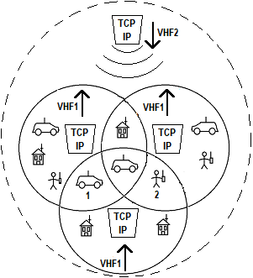
Figure: stations 1 and 2, which transmit simultaneously, collide for the receiver IGATE below but not for the other two receiver IGATES. The transmitting IGATE radiates its signal in the area of the three cells.

The transmitting IGATES, located in privileged geographical positions and different from the receiving IGATES, could operate on a different frequency in the same band as the receiving IGATES.
They would only transmit the traffic of the underlying IGATES receiving cells, plus the packets for which multiple digipeating is required, effectively replacing the digipeaters, with the difference that the transfer of the packets between transmitting cells would take place via the internet and not via radio. To share the transmission channel, neighboring transmitting IGATES would use the CSMA 1-persistent protocol, distant IGATES would simply not listen to each other.
Being able to operate IGATES transmitters and receivers on the same band would allow terminal stations to use the current equipment by simply setting an offset between transmission and reception, without the need to use dual band equipment.
Also in this case terminal stations would accept the small loss of information in the short time interval during which they transmit.
Of course the traffic could also always be viewed on the internet as it happens now.
Even higher performances could be obtained by operating the transmitting IGATES on different frequencies eliminating the contention access problems on the downlink channel: in this way each transmitting IGATE could exploit the capacity of its channel at 100%, being able to transmit up to 900 frames per network cycle of 20 minutes at a speed of 1200 bps with the maximum reliability allowed by the noisy radio channel, corresponding for example to 115 mobile stations that transmit an APRS packet every 5 minutes and 440 fixed stations that transmit an APRS packet every 20 minutes.
Such transmitting IGATES could easily serve very large areas or a large number of APRS stations.
Fixed stations should tune into the downlink frequency of their area; mobile stations could simply be tracked while they are in motion and, only when they reach their destination, tune their receivers into the downlink frequency of the arrival location to communicate in a bidirectional way.
Such solutions, certainly feasible in theory, pose however problems from a practical point of view regarding the availability of internet connections in isolated places, and the cost, because they require a very high number of internet connections.
A less expensive solution would be to make bidirectional IGATE cells with an intermediate coverage area, partly sacrificing the benefits in terms of the reduced number of collisions that derive from small listening cells.
These medium-sized cells, located in privileged locations for the coverage of a limited geographical area, but not remote, (aqueduct towers, bell towers, high buildings, any private house with a panoramic view), could easily have internet access, and using the same connection for traffic in both directions would halve the number of connections needed, and therefore the overall cost.
The cells would operate on separate frequencies for reception and transmission as proposed in the previous model but could hardly operate on the same band due to the interference that the transmitter would exert on the receiver at the IGATE.
Terminal stations should therefore use dual band equipment. The interconnection between the cells, of course, would take place via the internet.

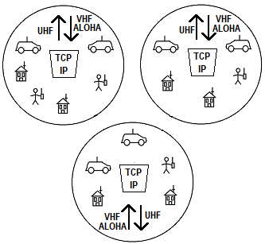
Figure: the network, divided into cells served by bidirectional IGATES and interconnected via the internet. Terminal stations transmit in VHF as soon as they have a packet to send and receive the data stream of their IGATE.

CONCLUSIONS

The analysis of the simple model proposed highlights the limits of the ALOHA protocol: random access to the shared channel heavily affects the maximum throughput, which cannot in any case exceed 18.4% of the total traffic at the maximum load conditions (50% of the channel capacity), and the probability of communication success under maximum load conditions is limited (36.8%).
Communication reliability improves when the traffic is low but the percentage of channel inactivity becomes very high, with a consequent significant waste of bandwidth.
The introduction of a digipeater in the network does not greatly reduce the overall performance in conditions of maximum load (maximum throughput 15.5% at a traffic equal to 42.2% of the channel capacity), and even less when the network is lightly loaded.
Instead, the presence of multiple digipeaters on the same frequency, necessary for multiple digipeating, heavily penalizes the performance of the individual cells and of the network as a whole, limiting the maximum number of stations, the throughput and the reliability of communications: the network can guarantee reliable communications only when the APRS stations are very limited in number.
Multiple repetition of the same packet along different paths increases the reliability of communication at the expense of an increase in network congestion.
To improve performance it is necessary to renounce the constraint of a completely isofrequency network: it is possible to equip the existing digipeaters with an additional uplink port leaving the operation of the current isofrequency network unchanged, but the most efficient solution that only uses radio communications is to fragment the network into cells operating on different frequencies and to articulate the network on two distinct hierarchical levels, local and interconnection between cells.
If you agree to use exclusively the internet for the collection and routing of packets, giving up the digipeaters, you can easily create particularly performing configurations with existing hardware, but the APRS network becomes web dependent and vulnerable in case of collapse of the normal communication channels, failing the primary function of aid to civil protection for which it was initially conceived.
The configurations identified in the previous pages are just some of the possible solutions; in any case, any solution must allow the reuse of existing equipment in order to be accepted by users.
Finally, one might wonder if it still makes sense to deal with an outdated technology such as APRS - and packet radio in general - certainly very limited by current standards; if this question is legitimate as far as performance is concerned, the fact remains that APRS and packet radio are still nowadays a valid tool for experimentation and personal education.

Bibliography

- W. Beech, D.Nielsen, J.Taylor “AX.25 Link Access Protocol for Amateur Packet Radio”, TAPR 1988
- R.Finch, S.Avent, “A duplex packet radio repeater approach to layer one efficiency”, 1987
- H.P. Van Tonder “Channel Throughput Enhancement of an Automatic Position Reporting System Network with MAC Layer Protocol Optimization”
- H.P. Van Tonder , “Improving Automatic Position Reporting System (APRS) Throughput and Reliability”, University of Stellenbosch, Dec 2004
- P. Loveall, “How APRS Works”, 2005 (PPT)
- B. Zielinski, “Effective throughput of AX.25 protocol”, Bulletin of the Polish Academy of sciences, Vol. 61, No. 3, 2013
- Maher H. Heal, “A Comment on the Throughput of Non-persistent CSMA”, Abu Dhabi University
- Paulette Altmaier, “A Short Tutorial on CSMA”, May 1991
- “K.W. Finnegan, “Examining Ambiguities in the Automatic Packet Reporting System”, December 2014
- The APRS Working Group , “Aprs protocol reference v.1.0”, August 2000
- Kenwood corporation, “APRS”, 1999
- Claire Goursaud, Yuqi Mo. , “Random Unslotted Time-Frequency ALOHA: Theory and Application to IoT UNB Networks”, 23rd International Conference on Telecommunications (ICT) , May 2016, Thessaloniki, Greece
- Sandro Petrizzelli, “Appunti di reti di telecomunicazioni”, cap 5 - protocolli di linea (parte II)
- Renato Lo Cigno, “Reti - Livello Collegamento: Data-Link e Medium Access Control”, Università di Trento

